

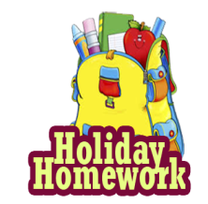

**SUMMER HOLIDAY HOMEWORK 2025-26**

**Class-III**

**Subject- English**

Q-1.Complete the following worksheets in your holiday homework **(Fun with Learning)** book.

1. Worksheet 1- Articles
2. Work sheet 2- Common and proper noun
3. Worksheet 3- Singular and plural
4. Worksheet 4- Countable and uncountable nouns
5. Worksheet 12- Opposite word (Antonyms)
6. Worksheet 23- words with same meaning ( synonyms )

Q-2. Learn and Write the definitions of Noun, Pronoun, Verb and Adjective with examples .

Q-3. Improve your cursive writing skills through regular practice,

Q- 4 Write 10 sentence about “My self”.

Q-5. Make a family tree on a chart paper and paste photos of your family members.

Q-6. Learn and write 2 new words daily along with their meanings.

Q-7. Prepare a noun chart with definition and illustrate examples in a flower pot diagram.

**Subject–Hindi**

1- नीचे दी गयी वर्कशीट को अपनी हॉलिडे होमवर्क **(Fun with Learning)** बुक में कीजिए-

(i)वर्कशीट –1,2,16,20 खेल खेल में

(ii) वर्कशीट - 3 क 4,5,11,15 वर्णो का ज्ञान

(iii) वर्कशीट - 10,14 ख, 17,19 वाक्य रचना

2- आठ पंक्तियो की कविता लिखें और याद करें |

3- गर्मी के मौसम पर पाँच वाक्य लिखिए –

4- हिन्दी वर्णमाला लिखें व याद करें |

5- प्रतिदिन अपनी पाठ्य-पुस्तक का एक पेज पढ़कर सुलेख करें |

6- प्रतिदिन 2- पर्यायवाची शब्द व 5- विलोम शब्द याद करके लिखें |

7- अपने विद्यालय पर 10 पंक्तियाँ लिखें |

8- इक्कीस (21) से पचास (50) तक हिन्दी गिनती लिखे |

**Subject**-Maths

Q-1.Complete the following worksheets in your holiday homework **(Fun with Learning)**book

i) Worksheet -1-8 Mixed bag

* Odd & Even
* Number names
* Place value
* Skip counting
* Expanded form
* Ascending/ Descending

II) Worksheet 9-11 Addition / Subtraction  
III) Worksheet 12-16 Multiplication

IV) Worksheet 21-27 Mixed bag

* Mixed word problem
* Times
* Months
* Shapes & Money
* Days

Q-2. Do Revision of Chapter- 1 and chapter-2

Q-3.Learn and write the tables form 2 to 20 .

Q-4.Write the roman numerals from I to L (1 to 50).

Q-5. Write the number names from -50 to 100

Q-6.Draw a place value chart on chart paper

Q-7. Make a model of place value.

**Subject-EVS**

Q-1.Complete the following worksheets in your holiday homework **(Fun with Learning)**book

1. Work sheet – 1 ( Family and friends)
2. Work sheet – 2 (Going to the mela)
3. Work sheet – 4 festivals
4. Work sheet – 6 Our Neighbourhood
5. Work sheet – 7Transport
6. Work sheet – 9 Plants and animals

Q-2.Create a colourful diagram of photosynthesis.

Q-3. Create a save water awareness poster on chart paper.

Q-4.Make a list of vegetarians and non vegetarians food.

Q-5.Write the name of 5 sense organs.

Q-6. Write some name of sources of water.

**Subject- Computer**

Q 1- Do the following worksheets in your holiday homework**(Fun with Learning)** book

1. Worksheet – 1 Parts of Computer
2. Worksheet – 2 Keyboard

Q 2- What is a computer and draw the picture of computer.

Q 3- Paste the pictures of input and output devices on a chart paper .

Q 4- Project work ( on chart paper)

1. IPO Cycle
2. Functions of operating system

Q-5.Book reading Form pg. no 35 to 53 .

**Subject**- G.K

Answer the Following Questions

Q1- Which is the fastest land animal ?

Q2- Which Planet do we live on ?

Q3- Which animal is known as the king of the jungle ?

Q4- Which animal gives us wool?

Q5- Who is the current Prime Minister and President of India ?

Q-6 Who was the first woman Prime Minister and President of India ?

Q-7 What is the capital of India ?

Q-8 Write the name of any 10 states and their capitals.

Q9- Activity work-

1. Paste 7 pictures of famous monuments and write their names(On chart paper)

**Subject – Drawing**

Q- 1 "Practice writing A to Z calligraphy letters in your notebook with the help of given examples.

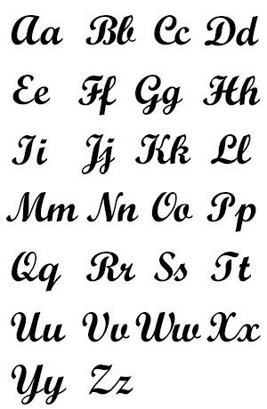

**Creativity corner :-**

**Prepare a Father’s day card, give it to your father and take a short video or pictures.**

1- Father' day Celebration on 15 June 2025

**Prepare a short video or take pictures related to any one activity**

1- Environmental day Celebration on 5 June 2025

2- Use any recyclable material like - plastic , bottle, cardboard boxes, old C.D and make any craft material

3- Reuse rain water

4- Plant any indoor or outdoor plant in your house

5- Any ecofriendly activity to save mother earth.

6- Implant Any seed in soil and observe its growth.

**Perform any one activity and prepare a short video or take some pictures.**

1- International Yoga dayCelebration on21 June 2025

2- Surya namaskar

3- Tadasana (Mountain Pose)

4- Vrksasana (Tree pose)

5- Bhujangasana (Cobra Pose)

6- Paschimottanasana (seated Forward bend)

**Note – (i) Revise the syllabus covered so far in every subject.**

**(ii) Use your subject notebook to solve question.**

**iii) 5 marks will be awarded in each subject in Periodic test-II for completing the holiday homework.**